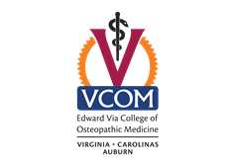 **Informed Consent Form**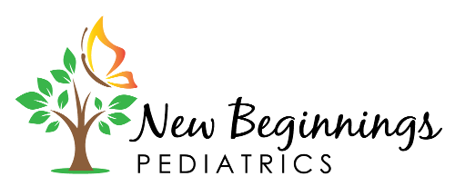

We are asking you to help us with a study. The purpose of this form is to share the information you need to participate in the study. Please read the form carefully. You may ask questions about the study to help you decide about participating. We will give you a copy of this form for your records.

Hello, First, thank you for participating in our study! The Edward Via College of Osteopathic Medicine, VCOM, is joining forces with New Beginnings Pediatrics in Blacksburg, VA to offer your children a future tailored nutrition program. To better understand your nutrition needs we are administering a brief survey to caregivers of patients aged newborn to six years old.

The survey will be distributed at the start of your visit and ask for information about your family and responses about your children’s eating patterns. Please feel free to complete the screening questions during the course of your visit and then drop the form off in the designated box in the waiting room of the office. Feel free to not answer questions that you choose not to respond to and skip to the next question.

No identifying information will be connected to your responses so we ask that you please give us an honest response to the best of your ability. These surveys are anonymous and only the investigators will be able to collect them from the drop-off box.

There is minimal risk associated with this research project and no compensation will be provided for your participation in this study. Although participants will not benefit from being in the study, we hope that you will take advantage of the free nutrition education classes we will be providing to the caregivers in this clinic in the near future.

You are free to choose whether or not to participate in this study. If you decide during the course of taking this questionnaire that you do not wish to continue, please note that you can withdraw at any time without penalty.

I have read this consent form and I volunteer to participate in this research study. I have had all of my questions answered.

Should you have questions about the conduct of this research, your rights as a research subject, or need to report a research-related injury, you may contact the VCOM IRB Chairman, P. Gunnar Brolinson, DO at (540) 231-3041 or [pbrolins@vcom.vt.edu](mailto:pbrolins@vcom.vt.edu)

**Principal Investigator:** Susan Meacham, PhD, RDN. Email: [smeacham@vcom.vt.edu](mailto:smeacham@vcom.vt.edu) Phone: 540-231-0907

**Co-Principal Investigators:** Dr. Sofia Abraham-Hardee, DO, PhD, Dr. Christina Kozar, DO, and Dr. Ancy Abraham, MD.

**VCOM Medical Students:** Jordan Hiegel, OMSI, Emilee Young, OMSI, Mayra Manchego, OMSI, Areeka Memon, MPH, OMSI, and Suhani Patel, OMSI.